LubeCon
Smart Lube 2000
Multi Function Lubrication System Controller
The purpose of this document is to provide a basic knowledge of the LubeCon System for the Extrusion Maintenance Department so that it may be used to both maintain the system and to facilitate its implementation into the remaining run-out tables. 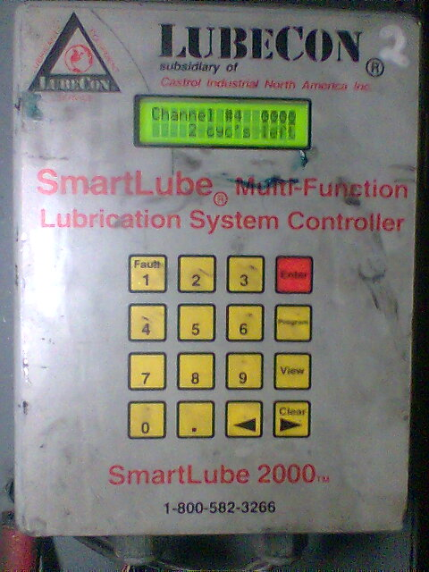

Starting with the main display, each controller consists of four separate channels. The statuses of these channels are represented by the four clock symbols in the upper right. At the time of this snapshot channel one was actively being displayed showing it in a "Wait" state as indicated by the clock symbol with the "Underline" beneath it. It is also showing a cycle count of 215 and a "Tick" count of 94 with both indicating how much "Run Time" remains until the next "Lube-Cycle". Which, when active, will be indicated by an Oil Can symbol in place of the clock symbol.

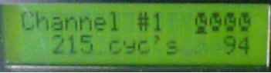

The artwork of the main circuit board within the controller is divided into 4 regions/channels from left to right with the outputs/Lube-solenoid drivers at the top and the inputs/Magnetic-pickup connections at the bottom. Several rows of terminal lugs exist numbered from left to right in two groups of eight. For the left region of eight, lugs 1-4 represent channel 1 and 5-8 represent channel 2. For the right region of eight, lugs 1-4 represent channel 3 and 5-8 represent channel 4.
1 grnd 4 5 grnd 8
1 grnd 4 5 grnd 8

Chnl 1 Chnl 2
Chnl 3 Chnl 4

Bus 1

Bus 2
The white wire which jumpers across bus 2:chan 1:pin 1 to chan 2:pin5 to chan 3:pin 1 to chan 4:pin 5 is a "Lube Request" signal from all 4 regions back to the pump station to start the pump whenever any of the regions reach the end of their "Wait Cycle" and need pressure to fire their solenoids to apply lubricant to their supported area. Bus2 chanl:1-pin:4 is the output for the solenoid for that region and a common for that solenoid can be picked up along bus:1. Channel:2 would be pin:8. On the right, Chan:3-pin:4 and Chan:4-Pin8. A small LED indicator on the top of the controller shares these connection points for each channel as an indicator for when the lube solenoid is firing.

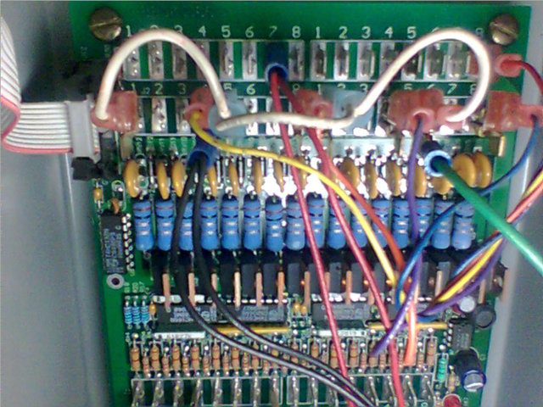

Bus 3, 4, and 5 maintain the same left to right regions as above but provide inputs from the magnetic pickups supporting each region/channel. With Bus:3 – pin:4 being the signal input, Bus:4 – pin:4 being the +24v supplied to the pickup, and Bus:5 – pin:4 being the ground for chan:1.

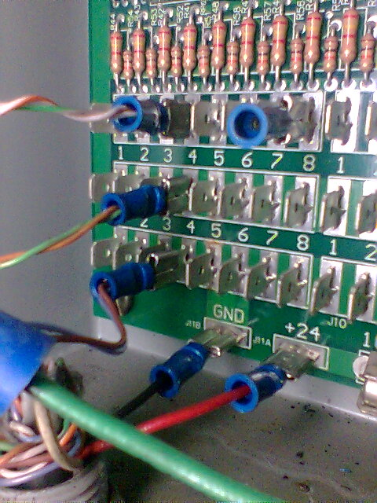

+24VDC is supplied from the pumping station to the controller via the connections beneath bus 5. 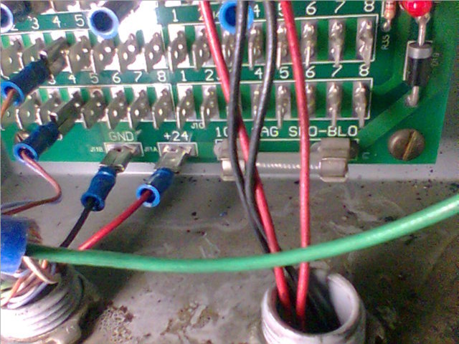

Routine Checks:

Daily checks should be made.

The inspecting individual should verify that each "Configured" channel is counting down by viewing the "Tick" count on the front controller display while the appropriate channel is being displayed and its monitored input is in motion. The Lube output jets should be inspected to insure that they have made it through the night without being damaged and are still aligned to point in parallel with the chain to allow the pulsed output of lubricant to lay on top of the chain hitting multiple links with each squirt.
The pump station should also be observed to insure that it is not in alarm, the lube line is holding pressure and the tank level indicator flag is not nearing empty. 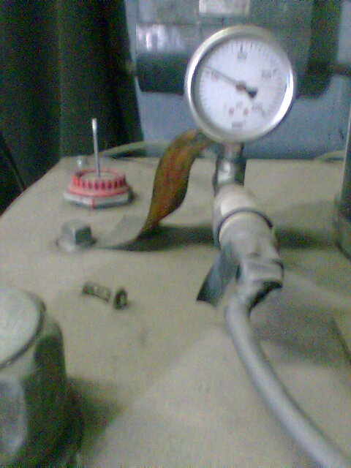

Pump station Control Panel
The low pressure alarm contact points were a programmable option... ($$$) So, a McMaster Carr P/N=3427K1 pressure switch was ordered, set, and placed in parallel with the tank Lube Level Switch. The whole point being to force an alarm and avoid pumping lube out onto the floor should the lube line get damaged, and it has, and it works. 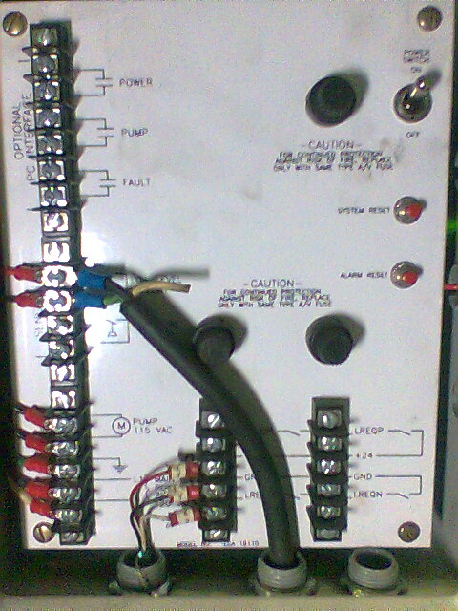
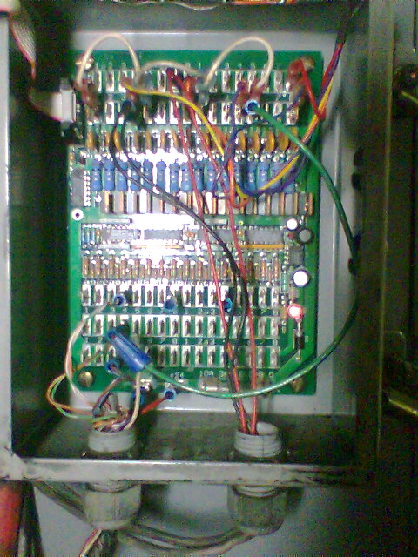
Zone 1
Zone 1

Controller Setup / Programming

Initially, intentions were to use Channel 1 for Run-out table #2s' Flight-Bar chain and Channel 2 for its primary chain drive. This would leave channel 3 and 4 to be used for identical purposes on press 1.

The individual channel profiles can be viewed/changed by entering program mode on the Controller by pressing <Prog>.

The following settings create a "Run time" counter which initiates one lube cycle for approximately every twelve and a half hours of actual run time. The lube cycle equals approximately 2 minutes 5 seconds. (The approximate time it takes for the run-out table to cycle / revolve one time.)

<Prog>
Controller replies with: "Password needed to edit"
(Use the number pad and left or right arrows to chose)

<1234>

<Enter>
Controller replies with: "Select Channel"
(Use left or right arrows to chose)

<1>

<Enter>
Controller replies with: "select channel 1 run mode"
(Use left or right arrows to chose)

<Counter>

<Enter>
Controller replies with: "Channel 1 on counts"
(Use the number pad and left or right arrows to chose)

<250> Indicates the number of "0.5 second pulses" which equal 1 cycle. (This value multiplied by the "Inter-count delay" will determine how long to apply lubricant once the Wait time / "Off Cycles" expire. (With current settings, 250 x 0.5 seconds equals 125 seconds.)

<Enter>
Controller replies with: "Channel 1 off cycles"
(Use the number pad and left or right arrows to chose)

<360> Indicates the number of cycles to "Wait/off cycles" between Lube cycles.
360 x 125 = 45000 seconds
45000 / 60 = 750 minutes
750 / 60 = 12.5 hours of "run time/wait time" between lube cycles.

<Enter>
Controller replies with: "Channel 1 on time"
(Use the number pad and left or right arrows to chose)

<.025> Indicates the length of time to hold Lube solenoid open between "lube on counts"

<Enter>

Controller replies with: "Channel 1 lube delay"
(Use the number pad and left or right arrows to chose)

<.025> Indicates the desired delay between lube applications. (This will be overridden by the fact that the "inter count delay" below is longer.)

<Enter>
Controller replies with: "inter count Delay"
(Use the number pad and left or right arrows to chose)

<0.5> This indicates the time delay between counting a pulse received by the magnetic pickup. This provides the base for our "Run Time" environment. (We look for a pulse/"Tick" every half second regardless of the sprocket speed.)

<Enter>
Controller replies with: "low lube shutoff"
(Use left or right arrows to chose)

<Enable> This is another input adjacent to the magnetic pickup inputs for use in other configurations. Enable it anyway...

<Enter>
Controller replies with: "High pressure shutoff"
(Use left or right arrows to chose)

<Enable> This is another input adjacent to the magnetic pickup inputs for use in other configurations. Enable it anyway...

<Enter>
Controller replies with: "restart channel?"
(Use left or right arrows to chose)

<Yes> This will restart the channel and initiate a lube cycle.

This can be done to manually initiate a Lube Cycle by simply entering Program mode and stepping/Entering through all settings (WITHOUT CHANGING ANYTHING!!!) to this point and choosing "yes".

<No> will end/save/close channel 1 configure settings without resetting the counters and starting a lube cycle.

<Enter>
Controller replies with: "enter channel to edit"
(Use left or right arrows to chose)

<Exit> Or, chose next channel to edit...

<Enter> If Exit is chosen, screen returns to main display.

NOTES:______________________________________________________________________________________________________________________________________________________________________________________________________________________________________________________________________________________________________________________________________________________________________________________________________________________________________________________________________________________________________________________________________________________________________________________________________________________________________________________________________________________________________________________________________________________________________________________________________________________________________________________________________________________________________________________________________________________________________________________________________________________________________________________________________________________________________________________________________________________________________________________________________________________________________________________________________________________________________________________________________________________________________________________________________________________________________________________________________________________________________________________________________________________________________________________________________________________________________________________________________________________________________________

